30.66: (a) Initially the capacitor behaves like a short circuit and the inductor like an open circuit. The simplified circuit becomes
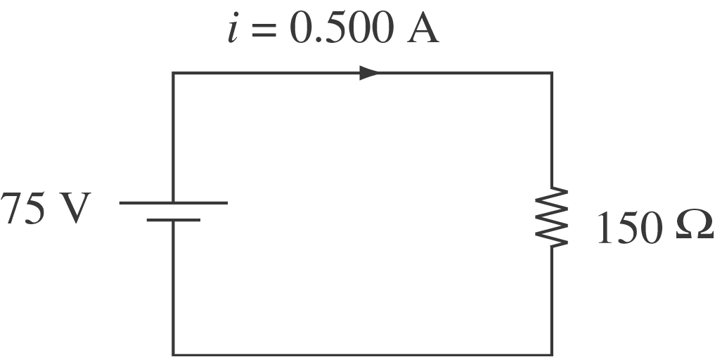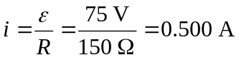
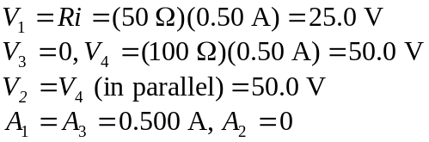
(b) Long after S is closed, capacitor stops all current. Circuit becomes
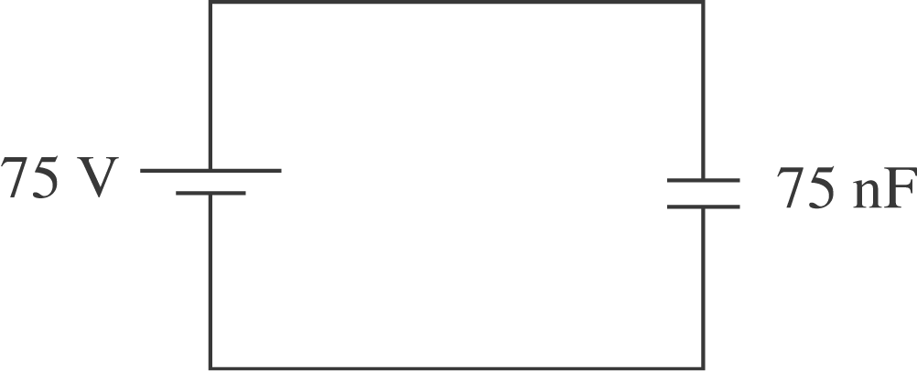 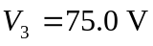 and all other meters read zero.
(c) long after S is closed.

